



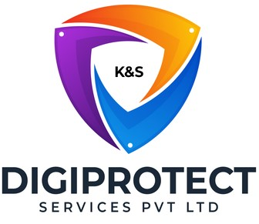

INITIAL
ASSESSMENT
REPORT

DATE: 28th June 2024
Finance –
Finance & Accounts, Treasury,
Investor Relations,
Loan Accounting

VERSION: 1.3

Document History
Document version | Remarks | Submitted  By | Submission  Date | Approved BY | Approval  Date
1.0 | First Draft | k&S Digiprotect | 29th May 2024
1.1 | Second Draft | k&S Digiprotect | 12th June 2024
1.2 | Third Draft | k&S Digiprotect | 24th June 2024
1.3 | Fourth Draft | k&S Digiprotect | 28th June 2024

Table of Contents
Introduction 4
Objectives 4
General Information 5
SPOC Information 5
Department Hierarchy* 6
Finance & Accounts Hierarchy* 6
Treasury Hierarchy* 7
Loan Accounting Hierarchy* 7
Observations 8
Data Flow Diagram (DFD) 14
Data Mapping and Inventory 15
Recommendations 17
Finance & Accounts 17
Treasury 17
Investor Relations 17
General Recommendations 18
Action Plan 18
Requirements (ISFC to share the following) 18
Conclusion 18
Appendices 19
Appendix A 19

Introduction
India Shelter’s Finance & Accounts department manages financial operations, including statutory returns, vendor registrations, vendor payments, employee incentives, and financial reporting, ensuring regulatory compliance and financial integrity.
Treasury is responsible for investment activities, co-lending with banks, and managing borrowings, they handle sensitive financial data and oversee the company's investment portfolio. Treasury is responsible for fund raising from Banks and Financial Institution. They also ensure adequate liquidity and handle monthly ALCO meetings.
Loan Accounting Oversees Loan collection, Receipt creation in system, posting accounting entries, insurance premium payments to vendors, refunds/Claims received from Insurance vendors, refunds to borrowers, loan account rescheduling (Part-payment/ROI change/ etc), and reconciliation of funds credited in bank with credit provided in Books. Similarly, oversees, Disbursement approvals, disbursement Payments, posting of accounting entries and its reconciliation.
They work out monthly income (Interest/Fee/Charges) and recognize it in books, similarly, finalizing monthly portfolio and posting related accounting entries for reporting purposes.
Investor Relations acts as the communication bridge between India Shelter and its investors, by managing investor communications, queries, and updates, while handling sensitive investor data and regulatory reporting.
India Shelter’s Finance & Accounts, Treasury, Loan Accounting, and Investor Relations teams within the Finance Department handle sensitive data, of and from financial transactions and statutory returns to personal information of customers and employees.
This report presents insights gathered from an initial interview conducted with the Finance department of India Shelter Finance Corporation for the purpose of advancing towards the implementation of ISO/IEC 27001:2022 standards and ensuring compliance with the Digital Personal Data Protection Act (DPDPA).
The primary objectives of this interview were twofold: firstly, to gain a comprehensive understanding of the department's structural framework, and secondly, to dive deep into its core operational processes. Furthermore, the interview sought to evaluate the existing information security protocols, with a specific focus on gauging the readiness for ISO 27001:2022 adoption and aligning with the requirements of the DPDPA.
By meticulously examining the organizational architecture, operational workflows, and data management procedures of the Treasury Department, this report endeavours to identify both its strengths and areas necessitating enhancement in information security management and compliance with the DPDPA mandates.

Objectives
- Understand the departmental hierarchy and reporting structure.
- Learn the existing processes of ISFC’s Finance Department.
- Mapping of existing processes with documented processes.
- Offer recommendations to optimize the existing processes.

General Information
Organization Name | India Shelter Finance Corporation Limited
Department Name | Treasury  Finance & Accounts  Investor Relations  Loan Accounting
Date of the Assessment | Treasury - 17th April 2024  Finance & Accounts – 19thApril 2024  Investor Relations – 22nd April 2024  Loan Accounting – 21st May 2024
Location | 3rd Floor, 6th Floor, India Shelter HQ, Gurugram
Meeting Duration | Treasury – 40 minutes  Finance & Accounts – 1 hr 30 minutes  Investor Relations – 40 minutes  Loan Accounting – 30 minutes
Attendees (ISFC) | Vikas Sharma, Vaman, Ajay, Prabuddh Bhatia, Madhur Sachdeva, Rahul Rajagopalan, Naresh Sharma, Dheeraj Yadav, Sunil Kumar Sharma
Attendees (Digiprotect) | Lalit Mohan Joshi, Sushil Menon, Adhita Razdan

SPOC Information
Project SPOC: Dheeraj Yadav
Contact Information:
Email ID: dheeraj.yadav@indiashelter.in

Project Coordinator: Sunil Kumar Sharma
Contact Information:
Email ID: sunil.sharma2@indiashelter.in

Department SPOC:
- Treasury – Vikas Sharma
- Finance & Accounts – Madhur Sachdeva
- Investor Relations – Rahul Rajagopalan
- Loan Accounting – Naresh Sharma
Contact Information:
Email IDs:
- Vikas Sharma: vikas@indiashelter.in
- Madhur Sachdeva: Madhur.Sachdeva@indiashelter.in
- Investor Relations: Rahul.Rajagopalan@indiashelter.in
- Loan Accounting: sharma.naresh@indiashelter.in

Department Hierarchy*
* As informed during the meeting

Finance & Accounts Hierarchy*
*As informed during the meeting

Treasury Hierarchy*
* As informed during the meeting

Loan Accounting Hierarchy*

* As informed during the meeting

Observations
S. No | Key Activities | Observations and Asks | Remarks
 | Finance & Accounts  - Regulatory returns are filed by this team. All data required for regulatory returns is handled by Chirag.  - Incentive calculation and payout is also handled by Chirag and this team. Shiv, Sunil, Neha create the incentive documentation for employees which is then sent to Chirag for final approval. Chirag further send it to the respective department heads for their review and approval; post which it is sent to the HR Ops team for final payment  - Accounts Payable for vendors is done by Rahul and his team. Getting invoices, paying invoices, processing invoices on the basis of PO and agreements with vendors, reconciliation of GA balances and books.  - Atul looks after GST, direct and indirect taxation along with returns related to direct and indirect tax.  - Balance sheet is prepared by Madhur and team,  - Vendor payment approval rights are reserved with Madhur.  - Investments are made through investment portals by the Treasury team, however in case approval is needed on urgent basis and treasury head is unavailable, the CFO has permission to grant approval of the same. 2 step approval process is setup for the investment portals.  - Money for investment in mutual funds is transferred from bank, which is approved by Treasury head, and again approved by Finance head.  - Invoices for vendor payments are processed in MS - D365.  - Invoices are segregated into two parts:  - For Legal and Technical vendors – vendor portal is used where the vendor directly raises the invoice, verification of the invoice is done by the finance team after which the invoice moves into the integrated accounting system used by ISFC.  - For other invoices – the invoice is raised with the HOD who will provide the first level of approval after which finance approves the invoice and is sent to the accounts payable team.  - Invoices are paid within 3-4 days after receiving necessary approvals.  - Services that are used monthly, approvals from HOD are as per agreement. Services that are used as and when required, the approvals are taken from HODs over emails.  - Vendor registration is done by the finance team. KYC documents of vendors are taken during this process.  - For entering into a contract with a vendor, approval from finance over the cost of services is done by:  - Madhur – up to Rs. 1 lakh  - CFO – more than Rs 1 lakh  - CFO + MD – more than Rs 25 lakhs | NA | - ISFC to appraise about GA balances  - ISFC to provide clarification on invest approval process. (Point g and point h)  - ISFC to provide clarification on Incentive calculation process, what all data is accessed during the same.
 | Treasury  - Investment  - For the investment process, the department determines investment goals and risk tolerances, conducts market research on investment opportunities and their viability.  - The investment transactions are also done by the treasury team, and documents are retained for record-keeping and compliance purposes.  - Co-Lending with Banks  - Borrowings  - Pool transactions are done where the due diligence is done by banks on the customers.  - The Loan documents (Property papers, KYCs, Loan Agreements and other anx. docs.) are made available to the Banks through online login (with special Auditor access) in the system.  - Bank conducting due diligence can download these documents in their system. | - Treasury team shares a lot of sensitive personal data on Co-lending platform including but not limited to Name, DoB, Address, Religion, Parents Name, Marriage status, Caste, Contact Details etc.  - Treasury team sends information to DA investors consisting of Name, DoB, Age, Income, KYC details. | - Treasury team shares and stores sensitive personal information of customers in plain text format.  - Treasury team to confirm if they have access to passports of Directors for sharing with regulators.
 | Loan Accounting  - Collection  - End-to-end collection reconciliation is done by the Loan Accounting team.  - These include EMI collection, Vendor collection, customer collections, loan closure(settlement), etc.  - Posting of accounting entries is also taken care of by the Loan Accounting team, including fund inflow, monthly revenue booking, loan adjustment.  - Disbursement  - After the loan application file is sanctioned by the operations team, the loan accounting team takes over for disbursement.  - Loan Payment is done in two modes: via NEFT/RTGS, and via cheque.  - Files are uploaded onto bank portals.  - Insurance Payment  - Insurance payments are done by the loan accounting team where they route the payments through the banks along with reconciliation (excess payments, etc.).  - Reverse refund reconciliation are also taken care by the team.  - When a loan is closed, and the insurance premium is refunded, it comes to ISFC’s loan account, and is then transferred to the customer.  - Monthly Portfolio Reporting  - Every month, the team reports on the AUM, interests, and income related to loans.  - Although most of the reporting is system-generated, the team performs additional work on the data to ensure accuracy and comprehensiveness.  - NHB/RBI compliances w.r.t. new notifications/circulars  - Ensuring relevant circulars/notifications are appropriately handled in LMS | NA | - The Loan Accounting team receives DM (disbursement) reports from Operations team which contains personal data of customers; however, Loan accounting team has no use for it.  - ISFC to describe the scenario where loan insurance is refunded.  - ISFC to explain the process for NHB/RBI compliances w.r.t. new notifications/circulars.
 | Investor Relations (IR)  - The core activity of Investor Relations is to act as a bridge between the company and investors.  - Investors are apprised about business performance, strategy, collection, state-wise issues faced, attrition rate of employees, among other updates.  - Investors queries are also looked after, along with connecting the investors with the concerned business heads.  - Feedback received from investors is shared internally.  - The mode of communication includes:  - Verbal Discussions  - Quarterly published reports  - Press releases  - Earnings Conference Calls (recorded) (Call duration is usually 1 hour)  - Investor Conferences  - Investor group meetings are recorded by the broker who hosts it and stored as per SEBI norms.  - Investor conferences are hosted by brokers and recording is done by them.  - IR has access to operational and financial data of branches as well as information regarding employees (ESOPs, attrition rates, etc.)  - IR receives BENPOS file every week from Registrar which contains the details of all shares bought/sold during the week. The file also has sensitive PII data of all the traders. The file can be accessed via a portal and downloaded as well.  - External meetings are conducted on Microsoft Teams, and Webex.  - IR has a vendor for designing the annual report. Information is shared over emails to the vendor.  - All data received by IR is stored on end point device. | - BENPOS file can also be accessed by CFO and Secretarial team. | - BENPOS file is received weekly by the department. It contains sensitive personal information of all personnel that have transacted with the ISFC stock during that week, including NRIs, personnel of national security (if they have traded the stock). The department tracks institutional investors via the BENPOS file but not the individual investors.  - BENPOS file needs to be stored in an encrypted format.  - No personal information is shared to the vendor designing the annual report.

Data Flow Diagram (DFD)
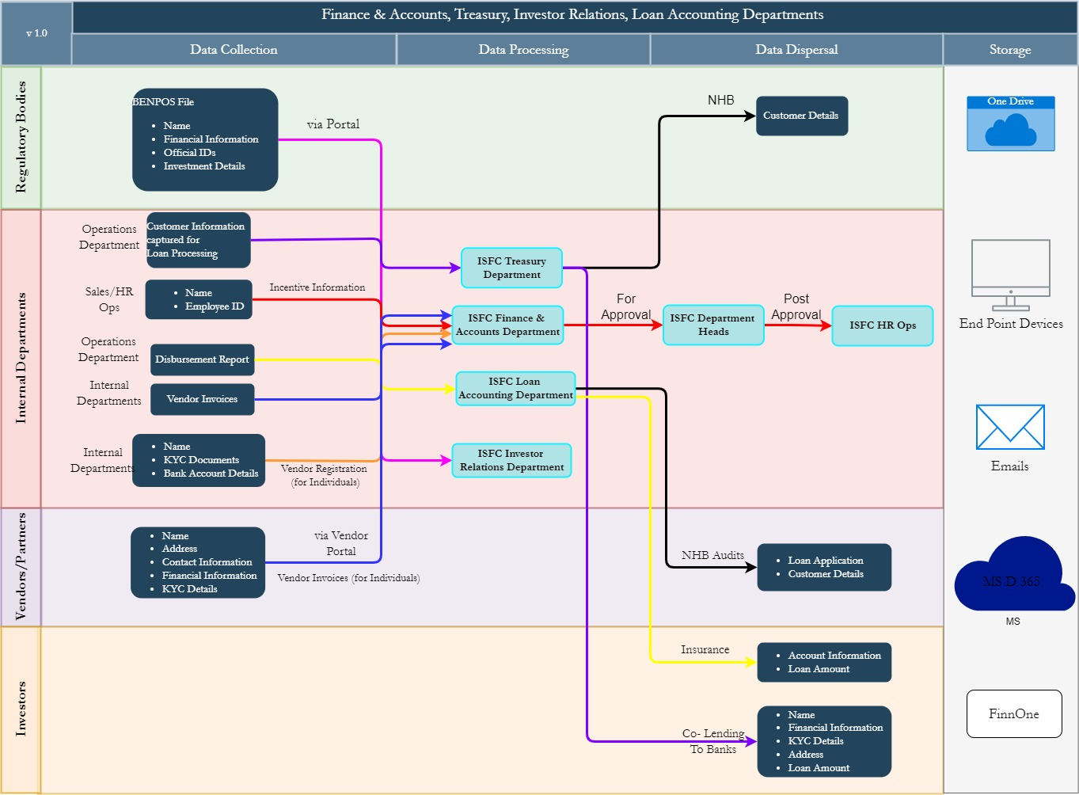

Data Mapping and Inventory
S. No | Data Category | Description | Purpose | Data Owner | Storage Location | Data Classification* | Retention Period | Legal Basis
1 | Financial Transactions of ISFC | Records of financial transactions, including payments and receipts | Manage financial operations | Finance & Accounts | MS - D365 | Non PII / Confidential | As per regulations | Legal Requirement
2 | Statutory Returns | Statutory returns filed for regulators | Regulatory compliance | Finance & Accounts | MS - D365 | Non PII/  Confidential | As per regulations | Legal requirement
3 | Employee Incentives | Incentive calculation and payout documentation | Employee compensation management | Finance & Accounts | MS - D365 | Non PII/  Restricted | Not Defined | Employment contract
4 | Vendor Registration | KYC documents of vendors collected during registration | Vendor management | Finance & Accounts | MS - D365 | Non PII/  Private | Not Defined | Legitimate Interest
5 | Vendor Invoices | Processing invoices through vendor portal and integrated accounting system | Invoice management | Finance & Accounts | Vendor portal, MS - D365 | Non PII/ Restricted | Not Defined | Contractual obligation
6 | Vendor Payments | Accounts payable for vendors, including invoice processing and payment | Vendor payment processing | Finance & Accounts | MS - D365 | Non PII/ Restricted | Not Defined | Contractual obligation
7 | Taxation | GST, direct and indirect taxation management | Tax compliance | Finance & Accounts | MS - D365 | Non PII/  Confidential | As per regulation | Legal requirement
8 | Financial Reporting | Balance sheet preparation and approval | Financial reporting | Finance & Accounts | MS - D365 | Non PII/  Confidential | As per regulation | Legal requirement
9 | Cash Management | Records of cash flow, including cash reserves and disbursements | Monitor and manage cash flow | Finance & Accounts | FinnOne | Non PII / Confidential | As per regulation | Legal Requirement
10 | Budgetary Information | Information pertaining to budget allocation and expenditure | Plan and manage financial resources | Finance & Accounts | FinnOne | Non PII / Confidential | As per regulation | Legal Requirement
11 | Investment Portfolio | Details of investments made by the ISFC | Manage investment activities | Treasury Team | Excel/ One drive/ Investment Portals | Non PII / Confidential | As per regulation | Legitimate Interest
12 | Co-Lending with Banks | Customer data shared with banks for due diligence | Co-lending operations | Treasury | Co-lending platform/ Excel | PII/Sensitive | Not Defined | Consent
13 | Loan Disbursement | Disbursement of loans sanctioned by the operations team via NEFT/RTGS and cheque | Loan disbursement | Loan Accounting | Bank portals/ Excel | Non PII/  Confidential | As per policy | Contractual obligation
14 | Insurance Payments | Insurance payments, reconciliation, and refund management | Insurance payment processing | Loan Accounting | Excel/One Drive | Non PII/  Confidential | Not Defined | Contractual obligation
15 | Portfolio Reporting | Monthly reports on AUM, interests, and loan-related income | Financial performance reporting | Loan Accounting | FinnOne/ Excel/Emails | Non PII/ Restricted | As per policy | Not Applicable
16 | Investor Communications | Communication with investors including reports, queries, and updates | Investor communication and compliance | Investor Relations (IR) | End point device | Non PII/  Confidential | As per policy | Regulatory and internal policy compliance
17 | BENPOS Files | Weekly BENPOS file containing details of all share transactions | Regulatory reporting and investor management | Investor Relations (IR) | Excel/ End point device | PII/Sensitive | Not Defined | SEBI regulations
*Refer Appendix A

Recommendations

Finance & Accounts
- Statutory Returns
- Ensure all statutory return data is encrypted both at rest and in transit.
- Maintain audit logs for all access and modifications to statutory return data for accountability.

- Employee Incentives
- Only collect and process necessary data for incentive calculations.
- Encrypt incentive documents to protect sensitive employee information.

- Vendor Payments and Invoices
- Ensure the vendor portal is secure by conducting regular security audits.
- Encrypt all vendor payment data and invoices stored in MS - D365.

- Vendor Registration and KYC
- Store KYC documents in a secure, encrypted environment.
- Conduct regular audits of vendor registrations and KYC processes to ensure compliance with data protection regulations.

Treasury
- Investment Portal
- Segregation of duties must be documented for investment portals to ensure compliance.

- Co-Lending with Banks
- Mask sensitive personal data wherever possible when sharing with banks.
- Ensure explicit consent is obtained from customers before sharing their data with third parties.
- Use secure methods for data transfer to banks, such as encrypted emails or secure file transfer protocols.

- Borrowings and Customer Data
- Protect personally identifiable information (PII) through encryption and access control.
- Implement data masking techniques for sensitive information like Aadhar and PAN details.

Investor Relations
- Investor Communications
- Encrypt all communication with investors, including reports and emails, to protect sensitive information.
- Store all data received and shared with investors on secure, encrypted devices and platforms.

- BENPOS Files
- Store BENPOS files in an encrypted format to protect sensitive trader information.

- Recorded Meetings
- Ensure recordings of investor meetings are securely stored on cloud storage with encryption.
- Restrict access to recordings to authorized personnel only.

- Annual Report
- Have data protection agreements in place with the vendor to ensure compliance with data privacy laws.

General Recommendations
- Data Classification and Handling
- Classify data based on sensitivity and implement handling procedures accordingly.
- Regularly review and update data classification policies.

- Data Retention Policies
- Define and implement clear data retention policies for all categories of data.
- Regularly review and update retention policies to comply with legal and regulatory requirements.

Action Plan

Requirements (ISFC to share the following)
- Policies, Procedures, SOPs of Finance & Accounts department

Conclusion
In conclusion, the initial analysis of the Finance & Accounts, Treasury, Loan Accounting, and Investor Relations departments reveals areas for improvement in information security and data privacy. Each department handles a wide array of sensitive and personal data, ranging from financial transactions and statutory returns to personal information of customers and employees. Ensuring the security and privacy of this data is paramount to maintaining compliance with legal requirements, protecting the organization's reputation, and fostering trust among stakeholders.
The recommendations provided are designed to address the specific observations and asks identified in each department. Key measures include implementing data encryption, using secure communication channels, and conducting regular security audits. By adopting these recommendations, ISFC can mitigate risks, safeguard sensitive information, and comply with relevant data protection regulations.
Moreover, the general recommendations for all departments emphasize the importance of data classification, and continuous compliance audits. These actions will create a robust security culture within the organization, ensuring that all employees are aware of their roles and responsibilities in protecting data.

Appendices

Appendix A
Data Classification | Definition
Sensitive Data | Information that, if disclosed, altered, or destroyed without authorization, could cause significant harm to an individual, organization, or entity. This often includes financial records, medical information, and PII.
Restricted Data | Highly sensitive data tightly controlled due to legal, regulatory, or contractual requirements. Access is limited to authorized personnel, and any unauthorized disclosure may result in severe consequences.
Private Data | Information considered confidential and intended solely for specific individuals or groups within an organization. It requires protection from unauthorized access to maintain privacy and uphold confidentiality agreements.
Confidential Data | Privileged or proprietary information of an organization requiring protection from unauthorized access, disclosure, or alteration.
Public Data | Information that is freely available and accessible to the general public without restrictions or limitations. It does not contain sensitive or confidential information and can be openly accessed and used for various purposes such as research, analysis, and public interest initiatives.
PII (Personally Identifiable Information) | Data that can identify, contact, or locate an individual, either alone or in combination with other information. For example - names, addresses, official identifiers (Aadhar, Pan, DL, biometrics, etc).
Non-PII | Data that, while not personally identifiable, however may still require protection due to its sensitivity or confidentiality. This may include corporate financial information, proprietary research data, or internal communications.
K&S Digiprotect Services Pvt. Ltd.
Date of Discussion: Date of Release:
Version: 1.0
Date of Release: 15th April 2024

-----------------------------------End of Report for Finance Department---------------------------------

